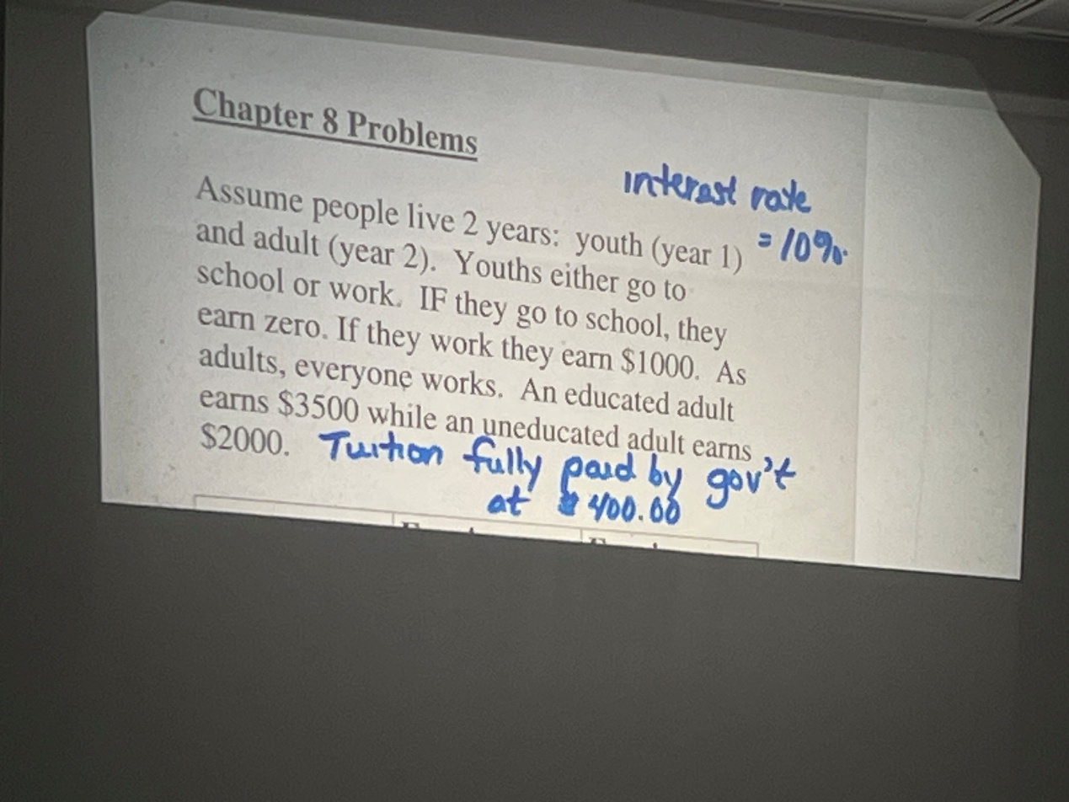

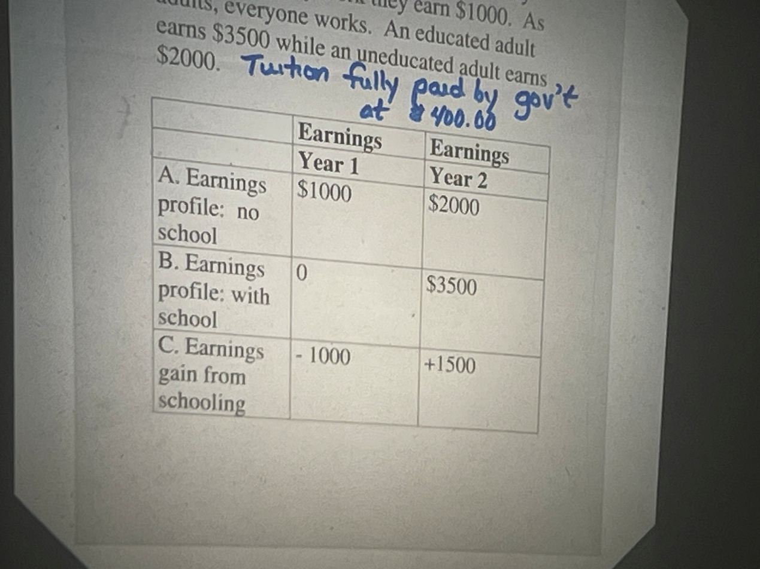

costs vs benefits

costs: indirect costs + direct costs

private social (adds in gov costs)

benefits: future + must discount

1+r

Private benefits and social benefits

In this case:

private cost = 100

social cost = 1000+400 (individual cost + government cost)

private gain = 1500/(1+r)

social gain = 1500/(1+r)

calculate dollar gain & cost

gain of return

net private benefit

Assume: interest rate = 10%

= 1500/1.1 -1000

= 364

Private rate of return:

1500/1+r = 1000

r = 50%

if interest rate is over 50%, then it is loosing money to go to school

net social benefit

= 1500/1.1 -1400

= -36.36 (loss)

Social rate of return:

1500/(1+r) = 1400

R = 7.14%

Two period model:

Discount of future costs,

NPV calculation:

Interest rate = 15%

= (gain/(1+r))+ (gain/(1+r)^2) - cost

Drop of saving rate only effect the saving function, and read everything vertically

Capital waiving line

Solow model:

Y = C+I

Y = C+S

=> S = I

K down due to d

N is positive

SS means K/L unchanged

S = n + d

Population down => giving a new line, and moving the intersection point along the line

s>n + d, K/L up, Y/L up

COMBINATIONSl

N down => K/L up, Y/L up, s> n+d

S down => K/L down Y/L down, S<n+d

When production line shifts up/down, saving function also shifts up/down

GiveL: PF = =Y/L = (K/L)^(1/2)

S(MPS) = 0.25

Philippines

Unemployment rate = 2.2%

A majotiey of people are self-employ, lack of stable job. Unstable job, low quality jobs

Educations high literacy rate 97.5%, education budget:

Universities enrollment rate 43.6%

New education system.

Promote sex education

Hire more teachers

15%of college graduates cannot find steady work

Create more jobs

Build new infrastructure, such as roads, bridges, and ports